From Class AM_functions
From def create_am_datfile
(Ln 133-140)
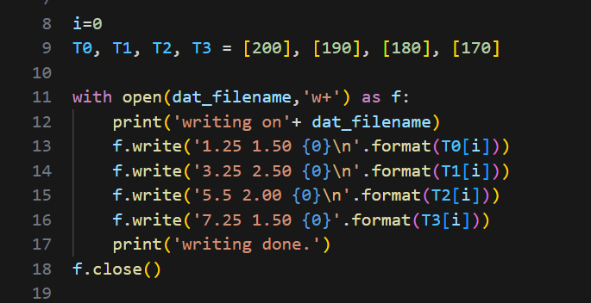
To write a dat file including the observing temperature.
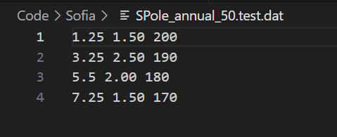

From def fit_w_am
(Ln 1316)
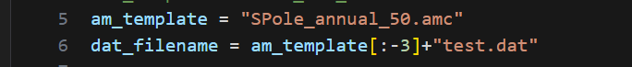
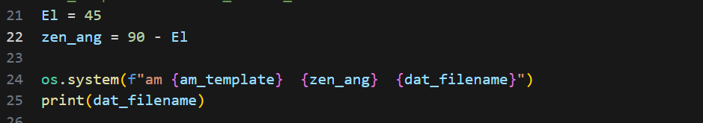

This SPole_annual_50.amc is different from the am cookbook
(left from cookbook, right Sofia’s fit amc)
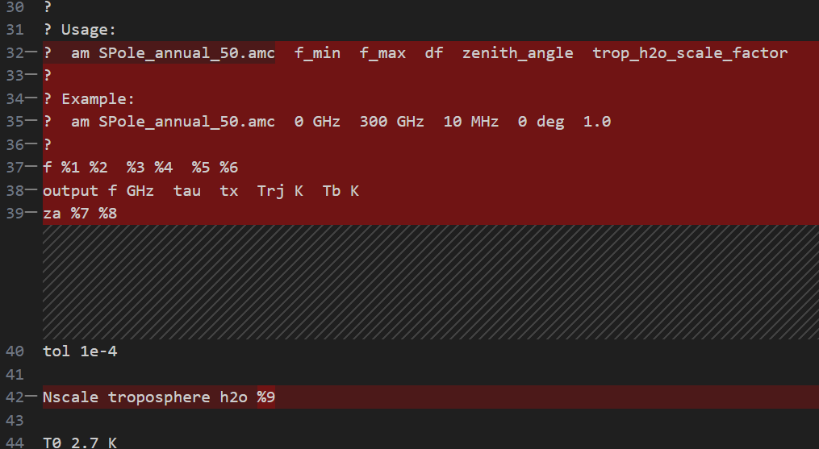
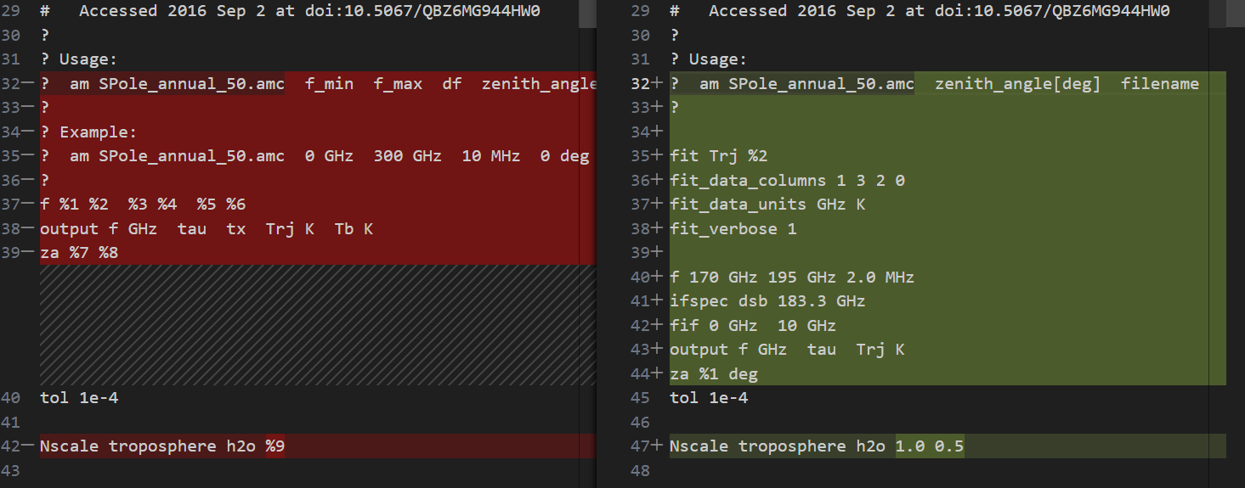

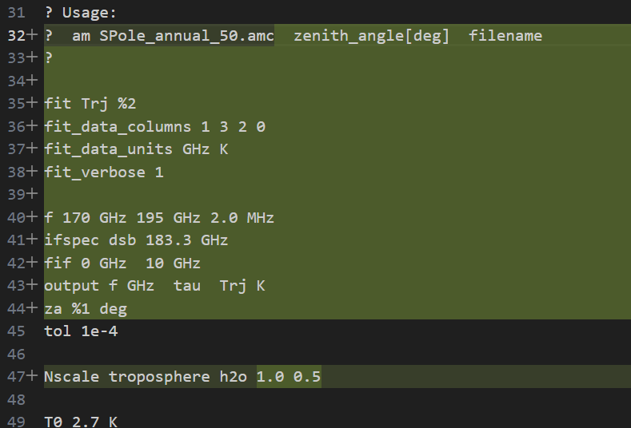

Use this fit amc file and dat file, we have this new amc file which is actually the .err file
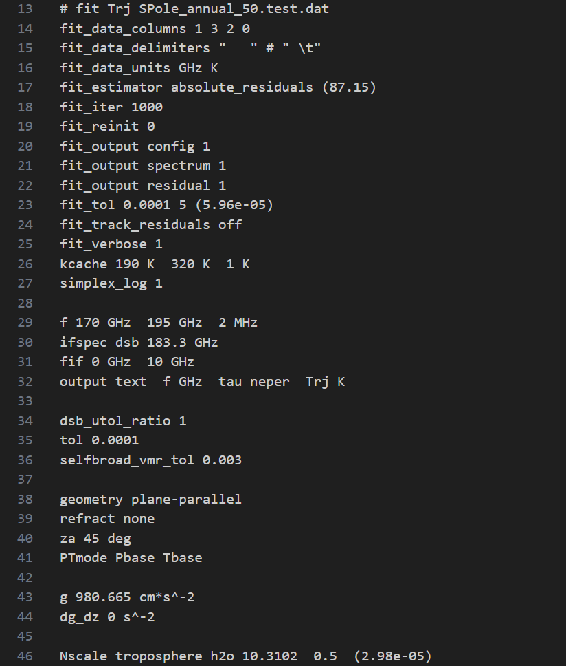

The third output file, datafile.amr, contains five columns; in order these are
$v_{i }{, r}_{i} , { s}_{i}^{mod},{ b}_{i}, w_{i}(weights)$
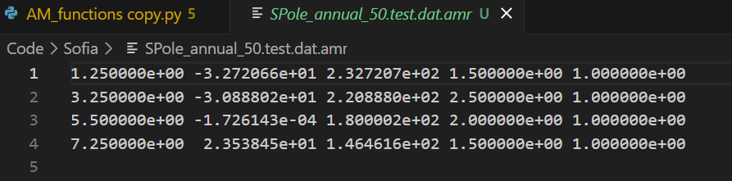
This ams file is the .out file
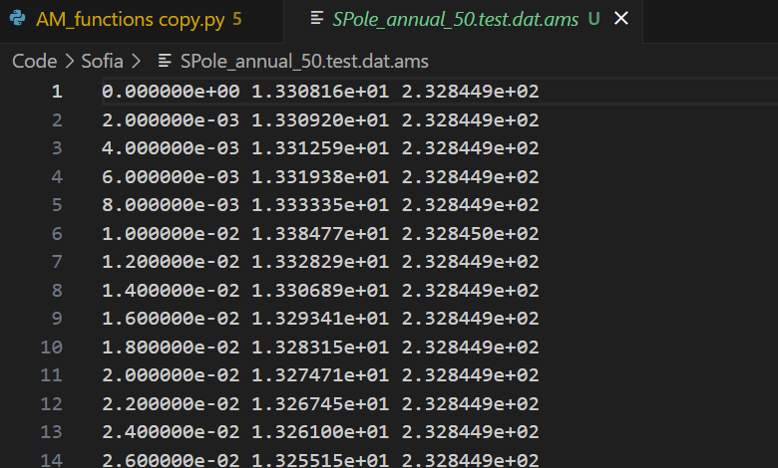

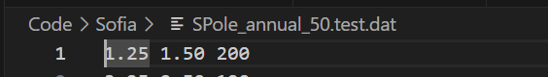
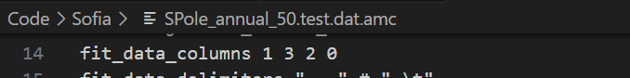
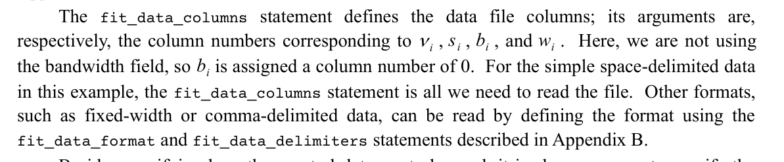
From amc, we expect the dat file as
frequence(v_i) bandwith(b_i) spectral data (s_i)
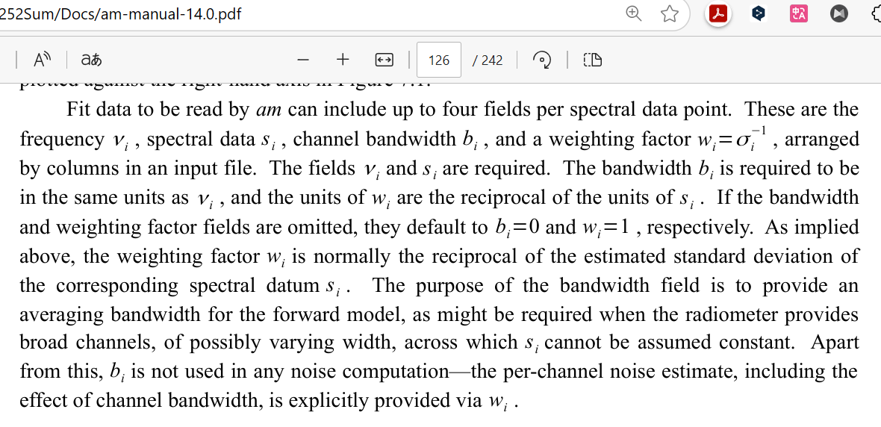

The difference between two amc files when have different value in dat fit file
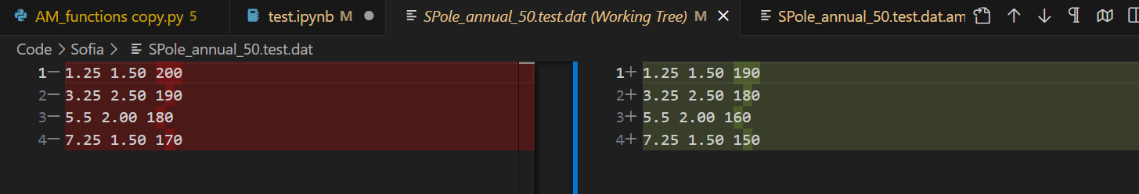

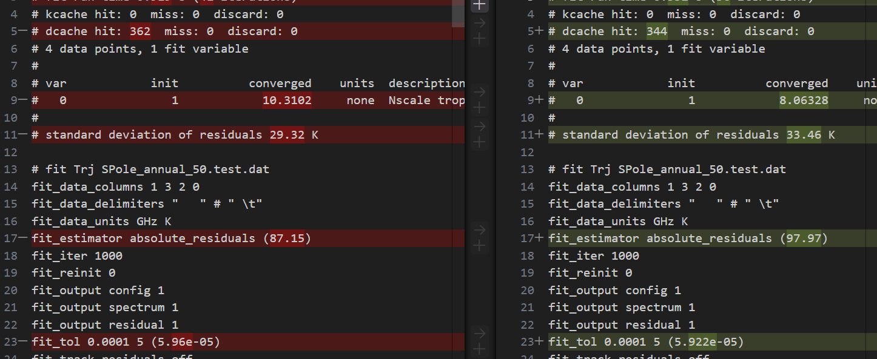
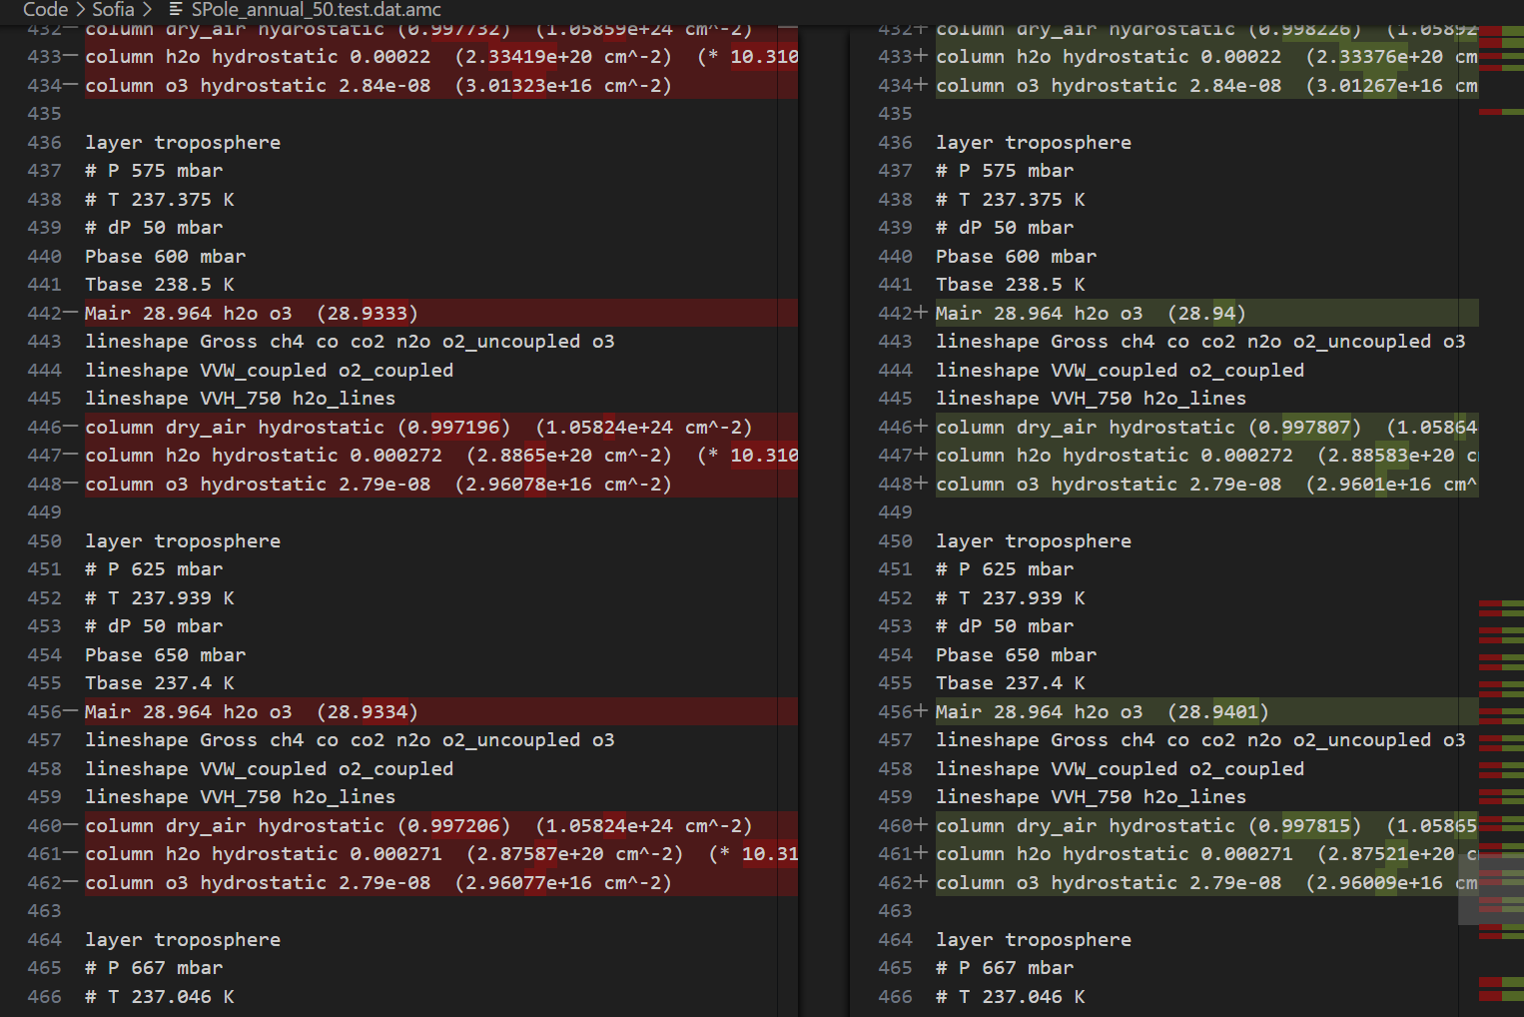
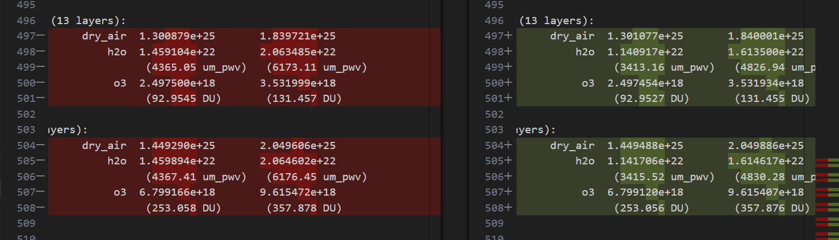

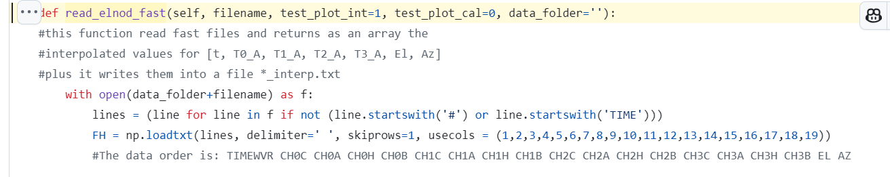
TIME TIMEWVR HOT_TEMP HOT_SETP
HOT_PWM COLD_TEMP COLD_SETP COLD_PWM
CHOP_PWM CHOP_CURR TP_TEMP TP_SETP
BE_TEMP BE_SETP BE_PWM CS_TEMP
CS_SETP CS_PWM LNA_TEMP TSRC0
TSRC1 TSRC2 TSRC3 EL AZ
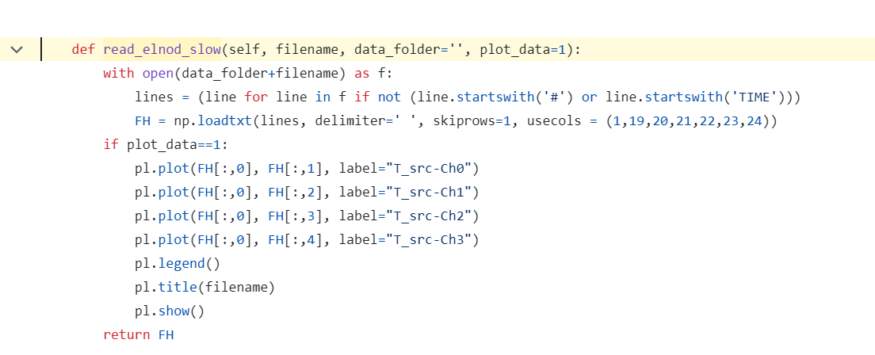
Take TIMEWVR TSRC0 TSRC1 TSRC2 TSRC3 EL AZ

